王庆松的“新闻摄影”

舒可文

那天我终于冒昧地问了王庆松，他的发型是怎么理出来的：99%的部分是光头，余下的1%长长的、稀稀疏疏的、几乎平均地分部在光头上。远点儿看，以为他秃得只剩下几根头发还好意思留那么长，两米以内看像是他头上套了一个薄薄的丝网。我一直很奇怪的是，他每次理发得花多长时间把长头发一根一根地绕过去。其实，他说不用，只是第一次处理了三个小时，他跟理发师说只许剃黑头发，白头发都留着。成型以后就好处理了，会用剃头推子的人都知道。

他精心处理的发型与他在摄影棚里精心设计的照片之间是否有趣味上的暗合，我不能确定，但在方法论上却是有着一致的倾向。

它们都被精心策划出一种似是而非的面貌。在他2000年左右的照片里他还是作为一个旁观者，比如在《过去、现在和将来》，以及《老栗夜宴图》里，尽管他有时候以表演者的形式出现在照片里，但表演者的身份在其中并不重要，在照片给出的信息里，“他”—制作者—依然是个旁观者。这个旁观者的身份在这里也不重要，给人深刻印象的是，这个旁观者向观众提供的物象有着一种似是而非的或庄重或享乐的气氛。说那是似是而非的，是因为画面里的欢喜气氛被一个看不见的界限控制着，如同他的秃头是一种似是而非的秃头。而那个旁观者在这种物象前表现出失去判断的停顿，又产生一种似是而非的兴趣，可这兴趣又显得木讷萎靡。
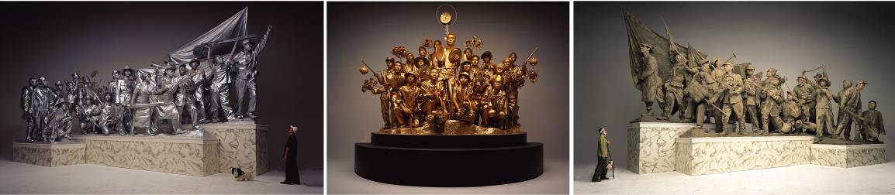
Past, Present and Future, 2001
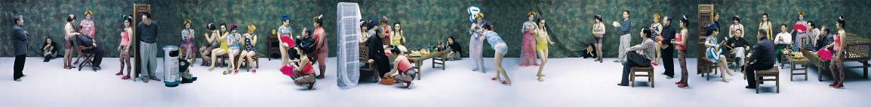
Night Revels of Lao Li, 2000
熟悉中国当代艺术的观众很自然地会从中读出那种反讽的趣味，但在王庆松的照片里还不是那种犀利明晰的反讽，他在很大程度上将反讽与所讽刺的对象相混淆，并且制造了一个精致的观赏化的外观。虽然依然是反讽的，但却使主体进入了更黑暗的部分，因此令人恐惧。我不知道这是不是他的策略，但至少是他的方法。

这种方法在他近几年的照片中依然沿用着，但手段似乎有了很大的变化，他自认为他的照片是“新闻摄影”，其实在背后推动他的还是一种反讽的欲望，尽管他不承认这一点。

不过，他的所谓“新闻摄影”在记录社会兴趣上确实有相似性。比如《跟我学》、《大摆战场》、《流浪汉》、《摄影节》等都有很大程度的“新闻性”。“跟我学”是20年前电视台的学英语节目，它的郑重其事和收视率可能是今天的新闻联播和电视剧都没法比的。相隔20年，王庆松在《跟我学》中追记的是那种急于成为世界公民的声势。《流浪汉》、《我们来了》和《摄影节》几乎就是通过摆拍复原的一个真实场景，当然在摆拍的设计中他会设计得更有典型的戏剧性。而《鲁迅-2004》就显得比较有解释的空间，如果鲁迅活在今天，他为鲁迅设计了一个冰雪轻盈的背景，鲁迅叼着烟斗蹲在一棵倒地的树边，手里拿着一本《鲁迅文集》沉思着？或疑惑着？这个尴尬的处境是推理或想象意义上的时事，按王庆松的理解，如果鲁迅活在今天，关于他的新闻一定就是这样的。《大摆战场》是一种双重的“新闻”，因为他在这里加用了夸张的手段，他借用的是文化革命中大字报的气氛和景象，而其中大字报被置换为泛滥于世的各类商业广告，所以其中既有关于广告已经铺天盖地的社会性记录，也有在大规模广告中显示的搞运动的惯性思维方式。这是一种对观念性和社会性的真实记录，这种双重记录显然是为了提示出一种历史的相似性。
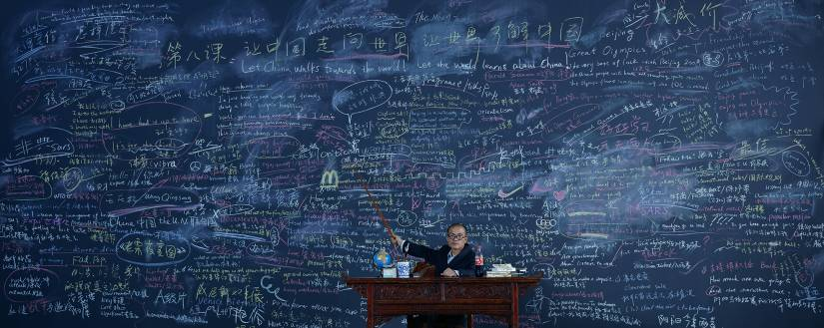
《跟我学》
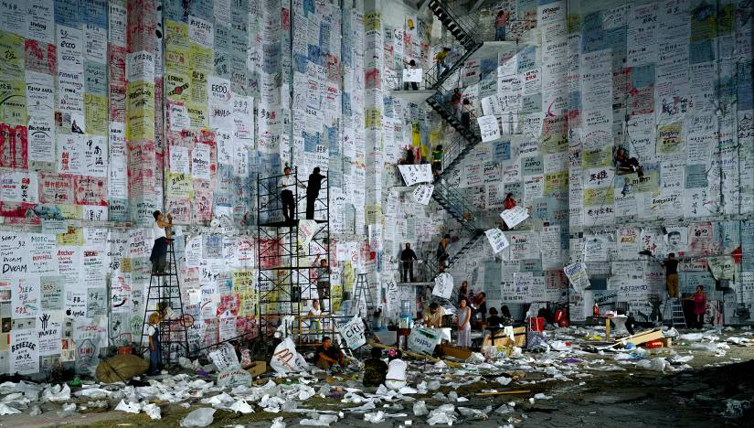
《大摆战场》
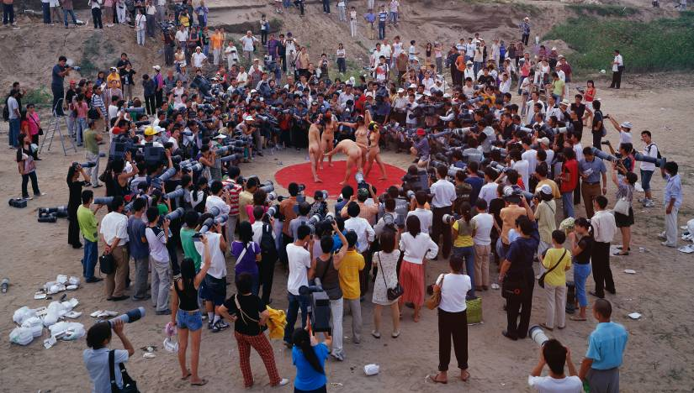
《摄影节》
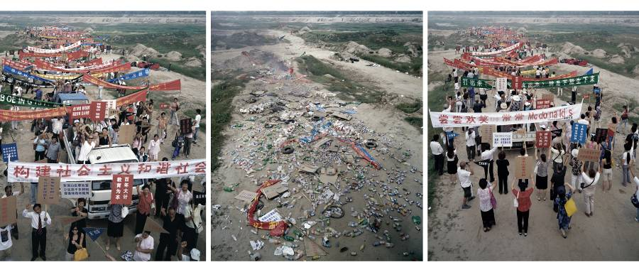
《我们来了》
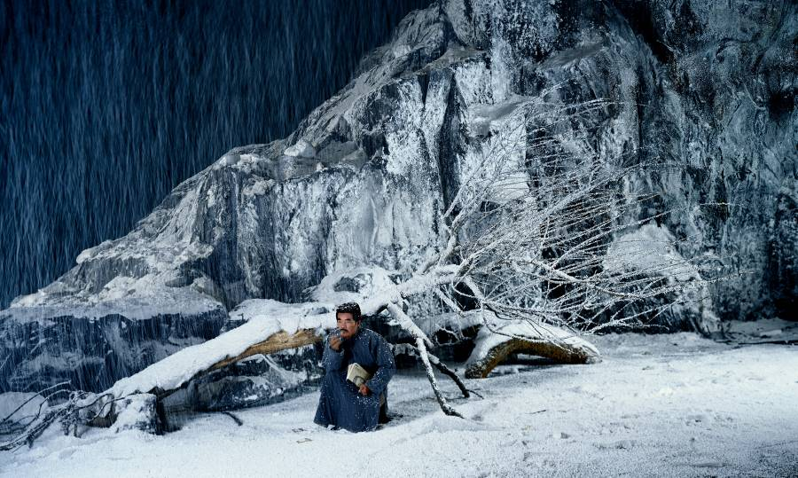
《鲁迅-2004》

借用是当代艺术最合法的一种手段。在王庆松的照片中，他借用了很多经典，或是经典画面，或是经典故事，比如《泉》、《中国之家》、《罗曼蒂克》、《思想者》或《瑶池相会》等等，在这些照片中，你可以看到波提切利的《春》、《维纳斯的诞生》，马奈的《草地上的野餐》、《奥林匹亚》，安格尔的《泉》和雷诺阿的《大浴女》，无数经典形象在这些照片上随处可见，然而都被他处理出一些令人不适的偏差。照片上的形象似乎变成了一种寄生物，她（他）们麻木而乏味，松散的身形和凌乱的目光缺乏任何意义的指向性，甚至缺乏身份的自我认同，在任何层次上都无法被命名。并且，裸体的使用一点也没有使情景变得自然飘逸，也没有变得躁动活跃，反而显出一种令人恐慌的、渗入肉体的无能为力。
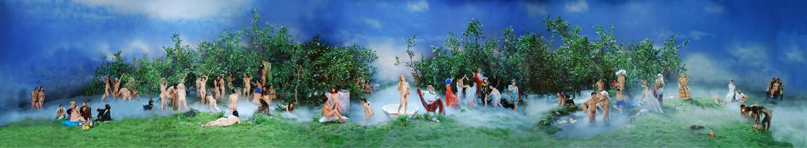
《罗曼蒂克》
《中国之家》
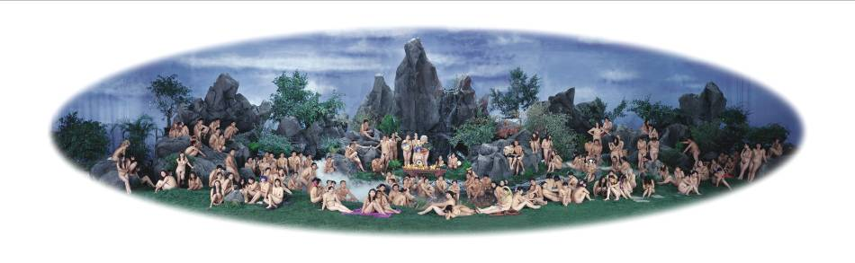
《瑶池相会》

这种挫败感在另一组照片中似乎能得到更直接的解释，这时他已经不再有耐心当旁观者了，如《毒蜘蛛》里，铁丝编成的巨大“蜘蛛网”上挂着最日常的商品而在《又一次战争》里，铁丝网上布满的是可口可乐罐子。这些从战争片中借用的场景再明确不过地表达着对商业文化的抵抗，可是这种抵抗在画面上表现得似乎也是无能为力的。
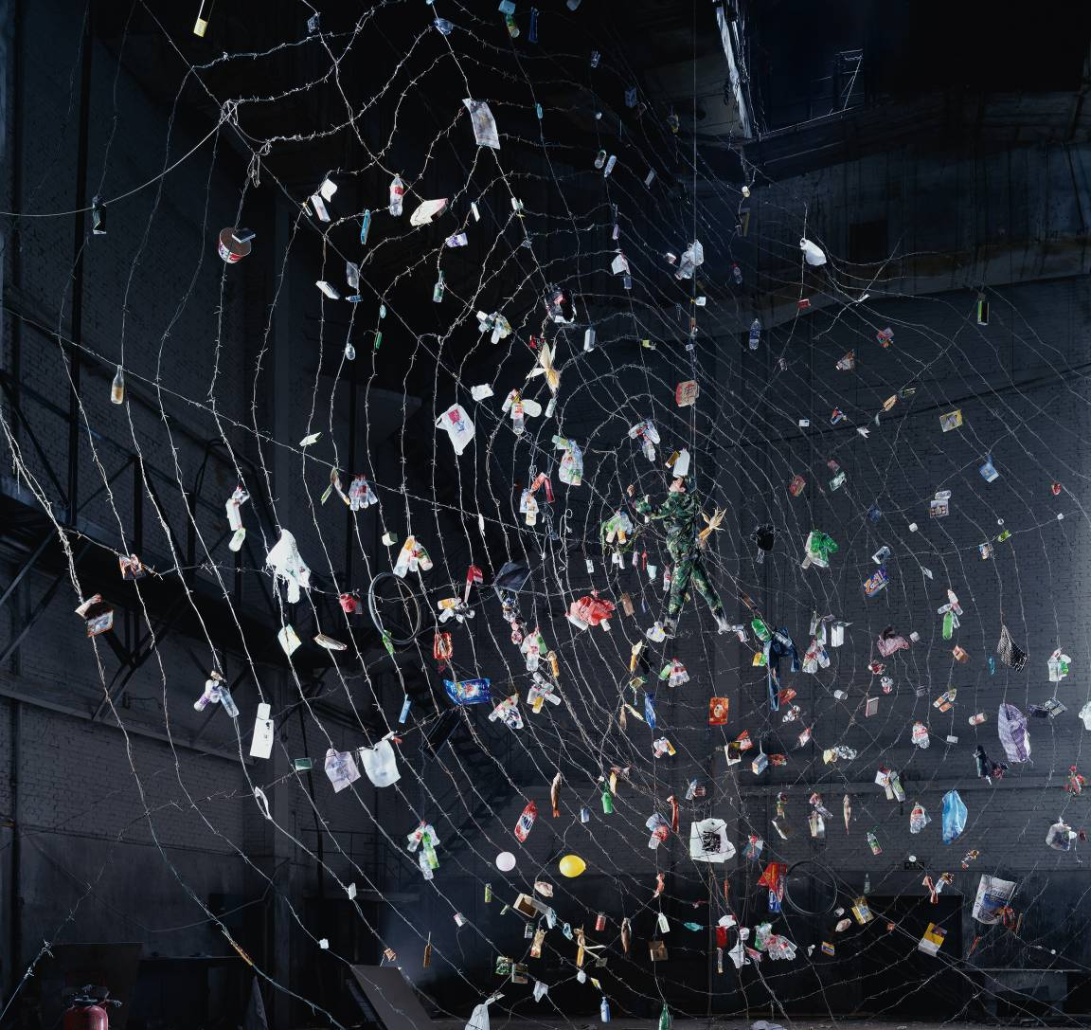
《毒蜘蛛》

无论是战士还是寄生者，在商业文化面前的挫败感如命运一样好像无法逃避，这些照片的意味到此已经由似是而非的暖色调转向了不知所措的荒诞色调。但是这种荒诞远不是现代主义戈多式的形而上荒诞，而是人在难以摆脱的自我否定中的现实荒诞。在这个意义上，王庆松自称的“新闻摄影”也是成立的。

Wang Qingsong's "Photojournalism"
Shu Kewen 2007

One day I finally asked Wang Qingsong how he cut his hair: 99% of his head is bald, and the remaining 1% sprouts long strands, scattered and dispersed almost precisely across his crown. Seen from afar, one might think he has gone bald to the point where only a few hairs remain, and wonder why he is not ashamed to let them grow so long. But from within two metres, it looks as if he has donned a thin net. I always thought it strange that he would spend so much time to work around these long hairs. But he said it did not take long, that the first time he spent three hours, asking the barber to cut only black hairs, leaving the white ones. After it had taken shape, the hairstyle was actually easy to manage, as anyone who has used hair clippers can attest.

As for whether there is any latent connection between his meticulous crafting of this hairstyle and his meticulous designs of images in the photographic studio, I cannot say, but there is some similarity at least in terms of methodology.

Both are meticulously planned, deceptive images. In his photographs from before the year 2000, Wang Qingsong was still an observer, as in "Past, Present and Future", and "Night Revels of Lao Li". Even if he sometimes appears in these images as a performer, the identity of the performer is not important at all. What leaves a deep impression is how the observer presents to the viewer an image of deceptiveness, either serious or playful. I say that this is deceptive because the image is controlled by an invisible limit, just as his head is deceptively bald. This observer placed before these scenes conveys the failure of judgement, producing instead a deceptive interest, but this interest itself comes to seem dull and listless.

Observers familiar with Chinese contemporary art can easily sense the satire at the heart of these works, but this satire is neither trenchant nor distinct. To a large extent he mixes his satire with its very objects, creating an exquisite external form. Although it remains satirical, the themes grow darker, coming to terrify its viewers. I don't know if this is his strategy, but at the very least it is his method.

This method recurs continuously throughout his recent works, but his tactics have changed greatly. He believes his images to be "photojournalism", when in actuality they are still driven by the urge for satire, even if he refuses to admit as much.

Still, his so-called "photojournalism" does have documentary interest in terms of recording a set of social interests. For example, his works "Follow Me", "Competition", "Beggar", and "Fotofest" all have a certain newsy character to them. "Follow Me" was an English-language instruction program on Chinese television twenty years ago, its viewership higher than any program currently on air. Twenty years later, Wang Qingsong's "Follow Me" picks up on this urgent desire to become a global citizen. "Beggar", "Come! Come!", and "Fotofest" were completed by fabricating a seemingly real scene, though of course these scenes are designed with an eye toward enhanced theatricality. "Lu Xun-2004" leaves a larger space for interpretation; as if Lu Xun were still alive today, Wang Qingsong has designed for him an icy, elegant background, Lu Xun holding a pipe in his mouth, squatting beside a fallen tree, holding a book of his own selected writings. Thinking? Perplexed? Is this awkward scene inferred or imagined? According to Wang Qingsong's interpretation, if Lu Xun were alive today, news about him would be just like this. "Competition" is a sort of double "news", employing the tactics of the Cultural Revolution "big-character posters" to create a certain image, but with the political slogans replaced with commercial logos. In this way he socially documents the omnipresence of advertising, even as he conceptually documents the implicit politics and movement-like tendencies at work behind this current commercial moment. This doubly documentary practice highlights historical similarities between two distinct eras.

Appropriation is one of the most legitimate strategies in contemporary art practice, and Wang Qingsong's photographs appropriate many classics, or rather classical images, or classic stories, as in "Fountain", "Home", "Romantique", "Thinker", and "Yaochi Fiesta". In these photographs, you can see Botticelli's "Primavera" and "The Birth of Venus", Manet's "Dejeuner sur l'Herbe" and "Olympia", Ingres's "La Source", Renoir's "Les baigneuses", and countless other classical images. And yet all have been rendered in slightly unrecognisable form, existing in parasitic relation to the originals. They are numb and vapid, scattered bodies and disorderly visions lacking any clear referent, devoid of identity and self-recognition, unnameable in any circumstance. The use of these bodies does not make the scene seem any more natural or elegant, any more restless or active, creating rather a sense of fear, a powerlessness that seeps into the bones.

This sense of frustration attains even clearer interpretation in another group of images. By this point Wang Qingsong lacked the patience to remain an observer as in "Poisonous Spider", where barbed wire form a giant "spider web" from which hang the most ordinary commercial goods, or "Another Battle", where the wire-fence is hung with Coca-Cola cans, its appropriated battlefield scene expressing a clear resistance to commercial culture. But in this work, even resistance comes to seem futile.

Whether warriors or parasites, the sense of frustration with commercial culture seems unavoidable in these works. Here, the warm colours of the earlier works have given way to an undeniably absurd tone. This absurdity is not the modernist metaphysical absurdity of Godot, but rather the real life absurdity of self-denial. Wang Qingsong's "photojournalism" is established in precisely this way.

